The complete test equipment consists in:
- A power supply
- Multimeter
- 2 cables with a banana connector in one end and a spade connector in the other end
- A light brown (dark yellow?) DIN96-connectorized custom board with an array of LEDs (see photo below)
- A blue DIN96-connectorized custom board with four pairs of socket connectors and two banana connectors (see photo below)
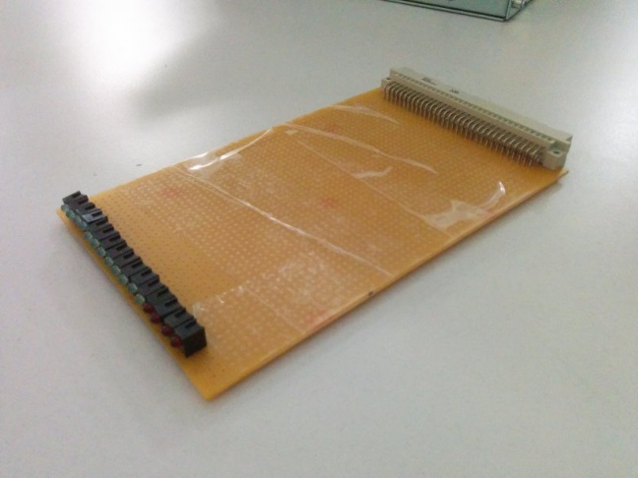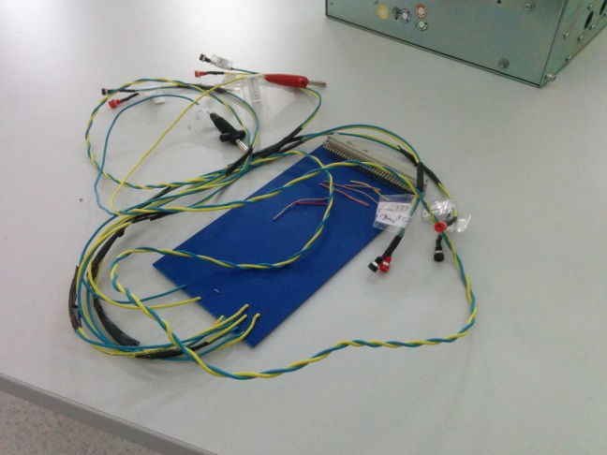

The test procedure is as follows:
- Test of lines C15, C16, C17, C18, can0l, can0h, can1l, can1h
Connect the blue board in any slot (except P20 and P21) and connect the banana connectors to the power supply (4.3 V).
Connect the brown board to every free slot, and verify that, in all of them, LEDs from #2 to #5 illuminate.
- Test of ground and power pins, and hardwired slot identification
Connect the power supply (4.3 V) to the crate power bolts in the pink front panel, black to GND and red to the corresponding partition.
Then proceed to insert the brown board to slots P7 to P19. All LEDs green LEDs, except for #2 to #5, should illuminate. Red LEDs should represent a binary representation of the slot number minus 7 (for example, for slot P9 it should be: OFF, OFF, ON, OFF).
Slots P7-P10 correspond to partition Vp1, P11-P13 to partition Vp2, P14-P16 to partition Vp3, P17-P19 to partition Vp4.
- Test of CAN bus termination status
The 4 socket pairs in the brown board can be used to verify the termination status of the backplane, when connected to slots P1 and/or P19. The labels in the sockets correspond to slot P1, but can also be applied to slot P19 (termXX_2 termXX_1).
For correct operation, the jumpers in the far end (far from P1 slot = OCB slot), K5, K6, K1, K2 should be connected to properly terminate the two buses, and the jumpers in the near end (near to P1 slot = OCB slot) should be disconnected, because the OCB has built-in terminations.
Thus, the resistances measured should be as follows:
- Can1h-Can1l = Can0h-Can0l = 100 Ohm
- In slot P19: Can1h-Term1h_1 = Can1l-Term1l_1 = Can0h-Term0h_1 = Can0l-Term0l_1 = 0 Ohm (short circuit)
- In slot P1: Can1h-Term1h_2 = Can1l-Term1l_2 = Can0h-Term0h_2 = Can0l-Term0l_2 = = OL (open circuit)

