

VME_PATCH
User Manual

Version 1.5

C. Fernández Bedoya, A. Navarro Tobar, J. Sastre Álvaro

CIEMAT

January 18th, 2012.

INDEX

1 VME_PATCH BOARD 5
2 VME_PATCH INTERFACES 5
3 VME_PATCH ADDRESSING 6
4 VME_PATCH BOARD REGISTERS 7

VME_PATCH BOARD
The goal of this board is to perform the bridge between the VME controller of the ROS and TSC crates (usually Linco VME controller) and the OFCU and TSC_rear modules.

VME_PATCH INTERFACES

The front panel has:

- DB-15 connector that contains four I2C buses with the following mapping:
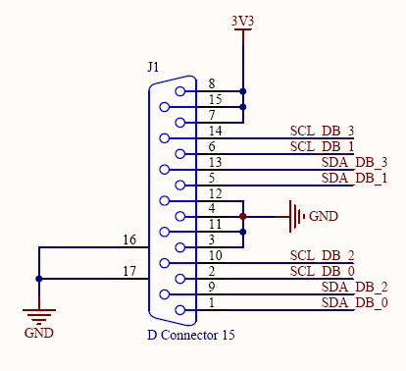
Figure 1: I2C DB-15 connector

- First row of leds. From left to right:
  - ON = 1.2 V ok
  - ON = 3.3 V ok

- Second row of leds. From left to right:
  - ON = All signal detects of the OFCU boards in the crate are OK
  - ON = VME access data acknowledge of the VME_patch (dtack)
  - ON = VME_patch FPGA properly programmed (done)

The backplane connections contain a J1 VME standard connector and a custom J2 to connect to the J2_OFCU backplane. The J2 mapping is (the signals in grey do not exist at present):

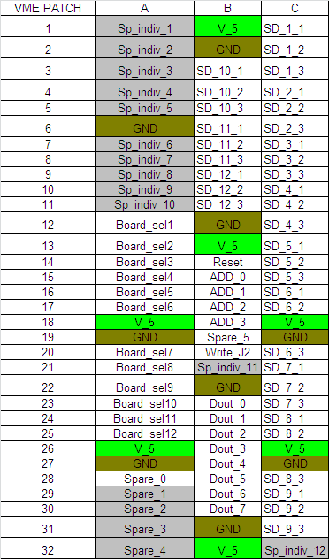
Figure 2: J2 VME_patch mapping

VME_PATCH ADDRESSING

The VME_PATCH board supports short non-privileged A16 D16 (Word) VME access. It translates it to the OFCU boards by means of a custom parallel protocol.

The A16 base address is selected with switch SW13, (A15-A10).
The address mapping for the registers of the different functional blocks is what follows:

A16 Base Address  (A15 – A10) | Functional block
VME_PATCH + 0x00 a 0x3E | VME_PATCH
VME_PATCH + 0x40 a 0x5E | OFCU slot 1
VME_PATCH + 0x80 a 0x9E | OFCU slot 2
VME_PATCH + 0xC0 a 0xDE | OFCU slot 3
VME_PATCH + 0x100 a 0x11E | OFCU slot 4
VME_PATCH + 0x140 a 0x15E | OFCU slot 5
VME_PATCH + 0x180 a 0x19E | OFCU slot 6
VME_PATCH + 0x1C0 a 0x1DE | OFCU slot 7
VME_PATCH + 0x200 a 0x21E | OFCU slot 8
VME_PATCH + 0x240 a 0x25E | OFCU slot 9
VME_PATCH + 0x280 a 0x29E | OFCU slot 10
VME_PATCH + 0x2C0 a 0x2DE | OFCU slot 11
VME_PATCH + 0x300 a 0x31E | OFCU slot 12

15 | 14 | 13 | 12 | 11 | 10 | 9 | 8 | 7 | 6 | 5 | 4 | 3 | 2 | 1 | 0
 |  |  |  |  |  | J2_3 | J2_2 | J2_1 | J2_0 |  |  |  |  |  | Vme BYTE

VME_PATCH BOARD REGISTERS

Reg1_vme (VME_PATCH + 0x00)
Default value = 0x0
Reset by a local_reset.

Bits | description | acc
0-5 | Dummy | R/W
6 | OFCU Reset | W | =1 reset (100 ns pulse). A reset will be sent sequentially to each OFCU.
7 | Local_reset | W | =1 reset of the VME_PATCH board only

All the registers from VME_PATCH are reset by a local reset.
A VME sys-reset will force also a reset in the VME_PATCH and in the OFCU boards.

Interruptions_Set (VME_PATCH + 0x02)
Default value = 0x0
Reset by a local_reset.

Bits | description | acc
0 | enable test interrupt | R/W | = 1 an interruption will be generated
1 | interrupt requested | R | = 1 an interruption from the VME_PATCH has occurred.
2-7 | Dummy | R/W

Interruptions_Vector (VME_PATCH + 0x04)
Default = 0x0
Reset by a local_reset.

Bits | Description | acc
0-7 | interrupt vector | R/W

Interrupt Level is always 7

SCL (VME_PATCH + 0x06)
Default = 0x1
Reset by a local_reset.

Bits | Description | acc
0 | SCL | R/W | SCL signal. The I2C bus you are addressing is selected in register I2C select.
1-7 | ‘0’ | -

SDA (VME_PATCH + 0x08)
Default = 0x1
Reset by a local_reset.

Bits | Description | acc
0 | SDA | R/W | SDA signal. The I2C bus you are addressing is selected in register I2C select.
1-7 | ‘0’ | -

I2C SELECT (VME_PATCH + 0x0A)
Default = 0x0
Reset by a local_reset.

Bits | Description | acc
0 | A0 – selection of I2C bus to address | R/W
1-3 | - | -
4 | A1 – selection of I2C bus to address | R/W
5-7 |  | -

0x00 => SDA0, SCL0
0x01 => SDA1, SCL1
0x10 => SDA2, SCL2
0x11 => SDA3, SCL3

SIGNAL DETECT OFCU 1-2 (VME_PATCH + 0x0C)
Default = 0x0
Reset by a local_reset.

bits | Description | acc
0 | Signal Detect OFCU=1, ROS ch 0-11 MB1and MB2 | R
1 | Signal Detect OFCU=1, ROS ch 12-23 MB3and MB4 | R
2 | Signal Detect OFCU=1, ROS ch 24 (single) MB4-b last | R
3 | Signal Detect OFCU=2, ROS ch 0-11 MB1and MB2 | R
4 | Signal Detect OFCU=2, ROS ch 12-23 MB3and MB4 | R
5 | Signal Detect OFCU=2, ROS ch 24 (single) MB4-b last | R
6-7 | -

SIGNAL DETECT
= 1 MEANS ALL OK (WITH J2_OFCU PROTOTYPE, ALSO NO OFCU BOARD CONNECTED )
=0 MEANS THERE IS A CHANNEL THAT IS IN NOT RECIVING SIGNAL

SIGNAL DETECT OFCU 3-4 (VME_PATCH + 0x0E)
Default = 0x0
Reset by a local_reset.

bits | Description | acc
0 | Signal Detect OFCU=3, ROS ch 0-11 MB1and MB2 | R
1 | Signal Detect OFCU=3, ROS ch 12-23 MB3and MB4 | R
2 | Signal Detect OFCU=3, ROS ch 24 (single) MB4-b last | R
3 | Signal Detect OFCU=4, ROS ch 0-11 MB1and MB2 | R
4 | Signal Detect OFCU=4, ROS ch 12-23 MB3and MB4 | R
5 | Signal Detect OFCU=4, ROS ch 24 (single) MB4-b last | R
6-7 | -

SIGNAL DETECT OFCU 5-6 (VME_PATCH + 0x10)
Default = 0x0
Reset by a local_reset.

bits | Description | acc
0 | Signal Detect OFCU=5, ROS ch 0-11 MB1and MB2 | R
1 | Signal Detect OFCU=5, ROS ch 12-23 MB3and MB4 | R
2 | Signal Detect OFCU=5, ROS ch 24 (single) MB4-b last | R
3 | Signal Detect OFCU=6, ROS ch 0-11 MB1and MB2 | R
4 | Signal Detect OFCU=6, ROS ch 12-23 MB3and MB4 | R
5 | Signal Detect OFCU=6, ROS ch 24 (single) MB4-b last | R
6-7 | -

SIGNAL DETECT OFCU 7-8 (VME_PATCH + 0x12)
Default = 0x0
Reset by a local_reset.

bits | Description | acc
0 | Signal Detect OFCU=7, ROS ch 0-11 MB1and MB2 | R
1 | Signal Detect OFCU=7, ROS ch 12-23 MB3and MB4 | R
2 | Signal Detect OFCU=7, ROS ch 24 (single) MB4-b last | R
3 | Signal Detect OFCU=8, ROS ch 0-11 MB1and MB2 | R
4 | Signal Detect OFCU=8, ROS ch 12-23 MB3and MB4 | R
5 | Signal Detect OFCU=8, ROS ch 24 (single) MB4-b last | R
6-7 | -

SIGNAL DETECT OFCU 9-10 (VME_PATCH + 0x14)
Default = 0x0
Reset by a local_reset.

bits | Description | acc
0 | Signal Detect OFCU=9, ROS ch 0-11 MB1and MB2 | R
1 | Signal Detect OFCU=9, ROS ch 12-23 MB3and MB4 | R
2 | Signal Detect OFCU=9, ROS ch 24 (single) MB4-b last | R
3 | Signal Detect OFCU=10, ROS ch 0-11 MB1and MB2 | R
4 | Signal Detect OFCU=10, ROS ch 12-23 MB3and MB4 | R
5 | Signal Detect OFCU=10, ROS ch 24 (single) MB4-b last | R
6-7 | -

SIGNAL DETECT OFCU 11-12 (VME_PATCH + 0x16)
Default = 0x0
Reset by a local_reset.

bits | Description | acc
0 | Signal Detect OFCU=11, ROS ch 0-11 MB1and MB2 | R
1 | Signal Detect OFCU=11, ROS ch 12-23 MB3and MB4 | R
2 | Signal Detect OFCU=11, ROS ch 24 (single) MB4-b last | R
3 | Signal Detect OFCU=12, ROS ch 0-11 MB1and MB2 | R
4 | Signal Detect OFCU=12, ROS ch 12-23 MB3and MB4 | R
5 | Signal Detect OFCU=12, ROS ch 24 (single) MB4-b last | R
6-7 | -

OFCU_RESET (VME_PATCH + 0x18)
Default = 0x0
Reset by a local_reset.

bits | Description | acc
0-7 | OFCU Slot to which a reset wants to be issued (75 ns reset pulse) | R/W

The number you write here is the OFCU slot (i.e. sector) to which a reset will be sent. 0x1 to reset OFCU from sector 1, 0x5 to reset OFCU sector 5, etc.

